**ASTANA IT UNIVERSITY**

**SOFTWARE QUALITY ASSURANCE**

**Test Reporting and Documentation**

**SOFTWARE TESTING IN THE CONTEXT OF SOFTWARE QUALITY ASSURANCE (SQA)**

**Project:** Online Banking System

**Test Phase:** Software testing

**Version:** 1.0

**Date Prepared:** 12.06.2023

**Prepared By:** Dana Orenkyzy, Arukhan Otarova

**Reviewed By:** Tleubayeva A.O.

**Last Updated:** 13.06.2023

**Last Updated By:** Dana Orenkyzy

**Link from Roadmap:** [ https://trello.com/b/lV5qYVkt/mb]

**Link to the Github repository:** [https://github.com/T1N1Rl/SQA/tree/main]

**Link to the Jira:**

[https://jirdone.atlassian.net/projects/MB?selectedItem=com.atlassian.plugins.atlassian-connect-plugin:com.deviniti.atlassian.apps.rtm__project-main-view#!/requirements/issues/243832]

**Astana, 2023**

**Context:**

Introduction……………………………….………………………………………………..… 3

Scope……………………………….………………………………………………..………...3

Objectives:……………………………….……………………………………………………4

* Requirements……………………………….…………………………………………4
* Test Case……………………………….……………………………………………...6
* Test Plan……………………………….………………………………………………8
* Test Execution……………………………….………………………………………...9
* Roadmap……………………………….……………………………………………..11
* Database……………………………….……………………………………………..12

Findings……………………………….………………………………………………..…….13

Defects……………………………….…………………………………………………13

Recommendation……………………………….…………………………………………….18

Conclusion……………………………….………………………………………………..… 19

Testing……………………………….…………………………………………………19

**Introduction**

The importance of testing in guaranteeing the dependability, security, and usability of online banking systems cannot be overstated. Online banking systems are sophisticated software applications that process sensitive financial transactions and user information. Thorough testing of these systems is required to discover and correct any flaws or vulnerabilities that might jeopardize the system's integrity or jeopardize user data.

The main purpose of testing an online banking system is to guarantee that it works properly and satisfies the standards. This includes ensuring that all features and operations, such as user identification, account management, fund transfers, bill payments, and transaction history, perform as intended. It also contains scenarios like valid and incorrect inputs, error handling, and system performance under various loads.

**Scope**

The following areas are frequently tested for in an online banking system:

* Functional testing entails ensuring that all banking system functions, such as account formation, fund transfers, bill payments, statement production, and user identification, perform as intended.
* Security testing consists of evaluating the system's resistance to illegal access and data breaches, as well as guaranteeing the confidentiality, integrity, and availability of important client information.
* Usability Testing: Evaluating the system's user-friendliness, such as simplicity of navigation, clarity of instructions, responsiveness, and accessibility for users of various devices and abilities.
* Performance testing involves determining the system's performance under regular and high load situations, such as response times, transaction throughput, and scalability to manage concurrent user activity.



**Objectives**

1. Requirement Executed

|  |  |  |  |
| --- | --- | --- | --- |
| Requirement ID | Requirement Description | Test Cases Executed | Test Case Status |
| MB-1 | The admin should be able to access the admin homepage. | MB-21 | Blocked |
| MB-2 | The admin should have the ability to log in and log out of the system. | MB-22 | Blocked |
| MB-3 | The admin should be provided with a navigation bar for easy access to different sections. | MB-23 | Pass |
| MB-4 | The system should provide a secure online banking experience for customers. | MB-24 | Blocked |
| MB-5 | The admin should be able to log in to the system using valid credentials. | MB-25 | In progress |
| MB-6 | The system should support the addition of customers. | MB-26 | Passed with restrictions |
| MB-7 | The system should support the addition of staff members. | MB-27 | Passed with restrictions |
| MB-8 | The system should allow customers to add beneficiaries for fund transfers. | MB-28 | In progress |
| MB-9 | The system should provide a process for verifying and adding beneficiaries. | MB-29, MB-35 | In progress |
| MB-10 | The system should support customer login and logout functionality. | MB-30 | In progress |
| MB-11 | Customers should be able to view their account summary. | MB-31 | In progress |
| MB-12 | The system should provide a process for verifying the ATM. | MB-32, MB-36 | Blocked |
| MB-13 | Customers should be able to request and process ATM card issuance. | MB-32 | In progress |
| MB-14 | Customers should be able to view their mini account statement. | MB-33 | In progress |
| MB-15 | Customers should be able to change their account password. | MB-34 | In progress |
| MB-16 | Staff members should have the ability to approve beneficiary requests. | MB-35 | In progress |
| MB-17 | Staff members should be able to approve ATM card issuance requests. | MB-36 | In progress |
| MB-18 | Staff members should be able to approve cheque requests. | MB-37 | Blocked |
| MB-19 | Staff members should be able to log in and log out of the system. | MB-38, MB-39 | Blocked |
| MB-20 | The system should provide a Frequently Asked Questions (FAQ) section for users. | MB-41 | Pass |

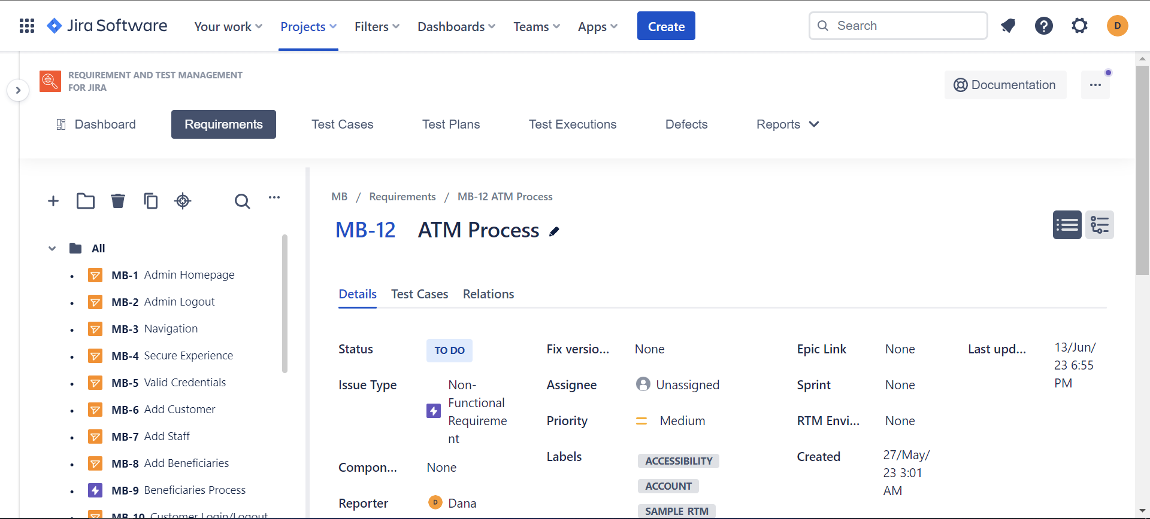

Fig1: Requirements from Jira

1. Test Case Execution:

|  |  |  |
| --- | --- | --- |
| Test Case ID | Description | Status |
| MB-21 | Verify that the admin can access the admin homepage after logging in. | Blocked |
| MB-22 | Verify that the admin can log out of the system. | Blocked |
| MB-23 | Verify that the admin has a navigation bar for easy access to different sections. | Pass |
| MB-24 | Verify that the system provides a secure online banking experience for customers. | Blocked |
| MB-25 | Verify that the admin can log in to the system using valid credentials. | In progress |
| MB-26 | Verify that the admin can add a new customer to the system. | Passed with restrictions |
| MB-27 | Verify that the admin can add a new staff member to the system. | Passed with restrictions |
| MB-28 | Verify that a customer can add a beneficiary for fund transfers. | In progress |
| MB-29 | Verify that a customer can log in to their account. | In progress |
| MB-30 | Verify that a customer can log out of their account. | In progress |
| MB-31 | Verify that a customer can view their account summary. | In progress |
| MB-32 | Verify that a customer can request an ATM card issuance. | Blocked |
| MB-33 | Verify that a customer can view their mini account statement. | In progress |
| MB-34 | Verify that a customer can change their account password. | In progress |
| MB-35 | Verify that a staff member can approve a beneficiary request. | In progress |
| MB-36 | Verify that a staff member can approve an ATM card issuance request. | In progress |
| MB-37 | Verify that a staff member can approve a cheque request. | In progress |
| MB-38 | Verify that a staff member can log in of the system. | Blocked |
| MB-39 | Verify that a staff member can log in of the system. | Blocked |
| MB-41 | Verify that the system provides a Frequently Asked Questions (FAQ) section for users. | Pass |

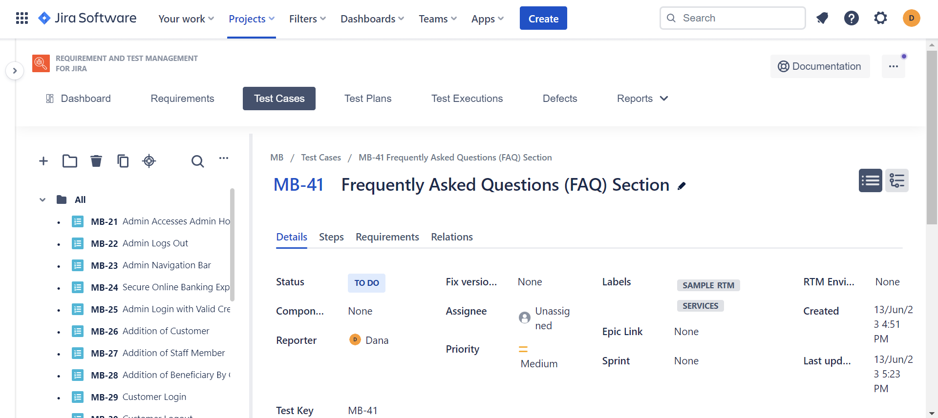

Fig2: Test Cases from Jira

1. Test Plan

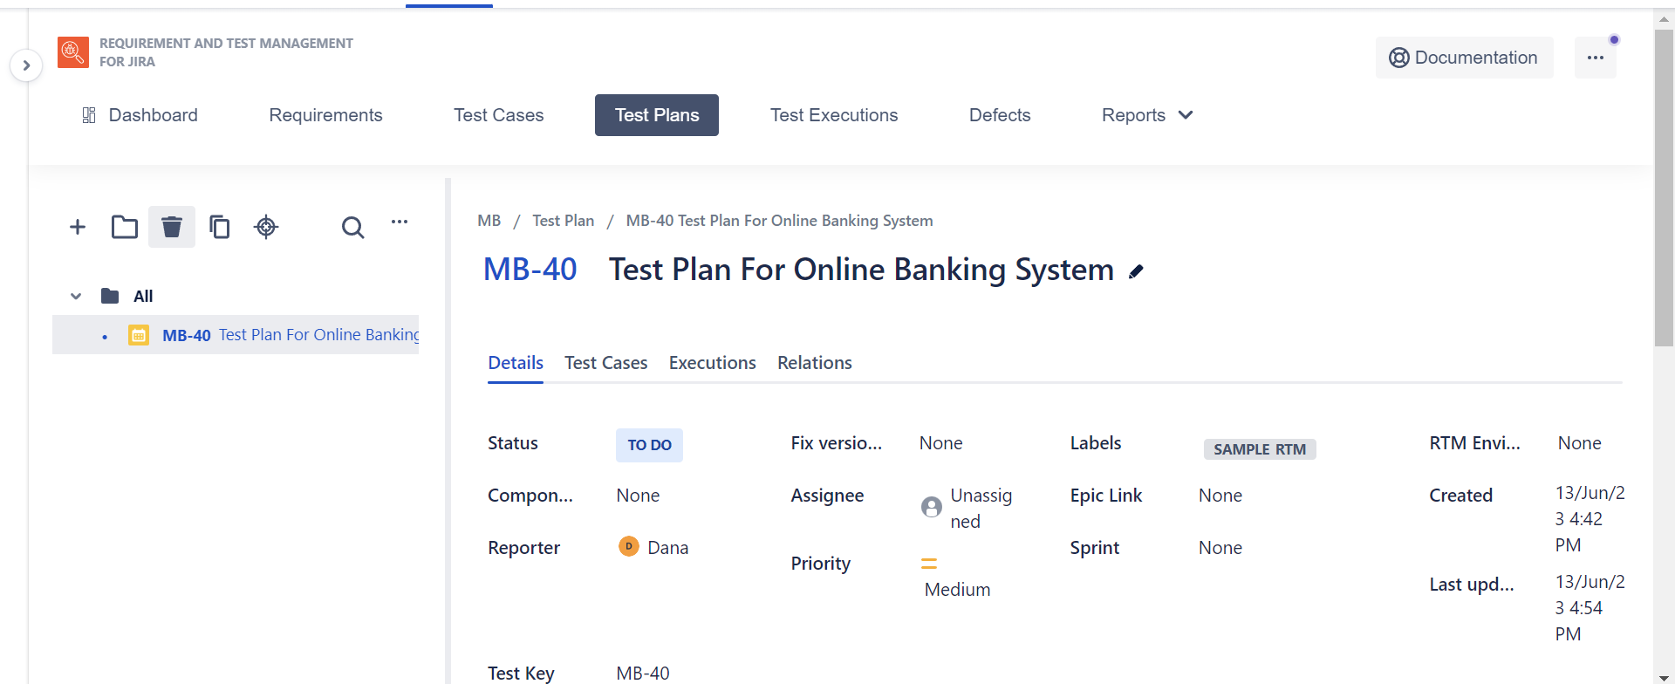

Fig3: Test Plans from Jira

1. Test Execution

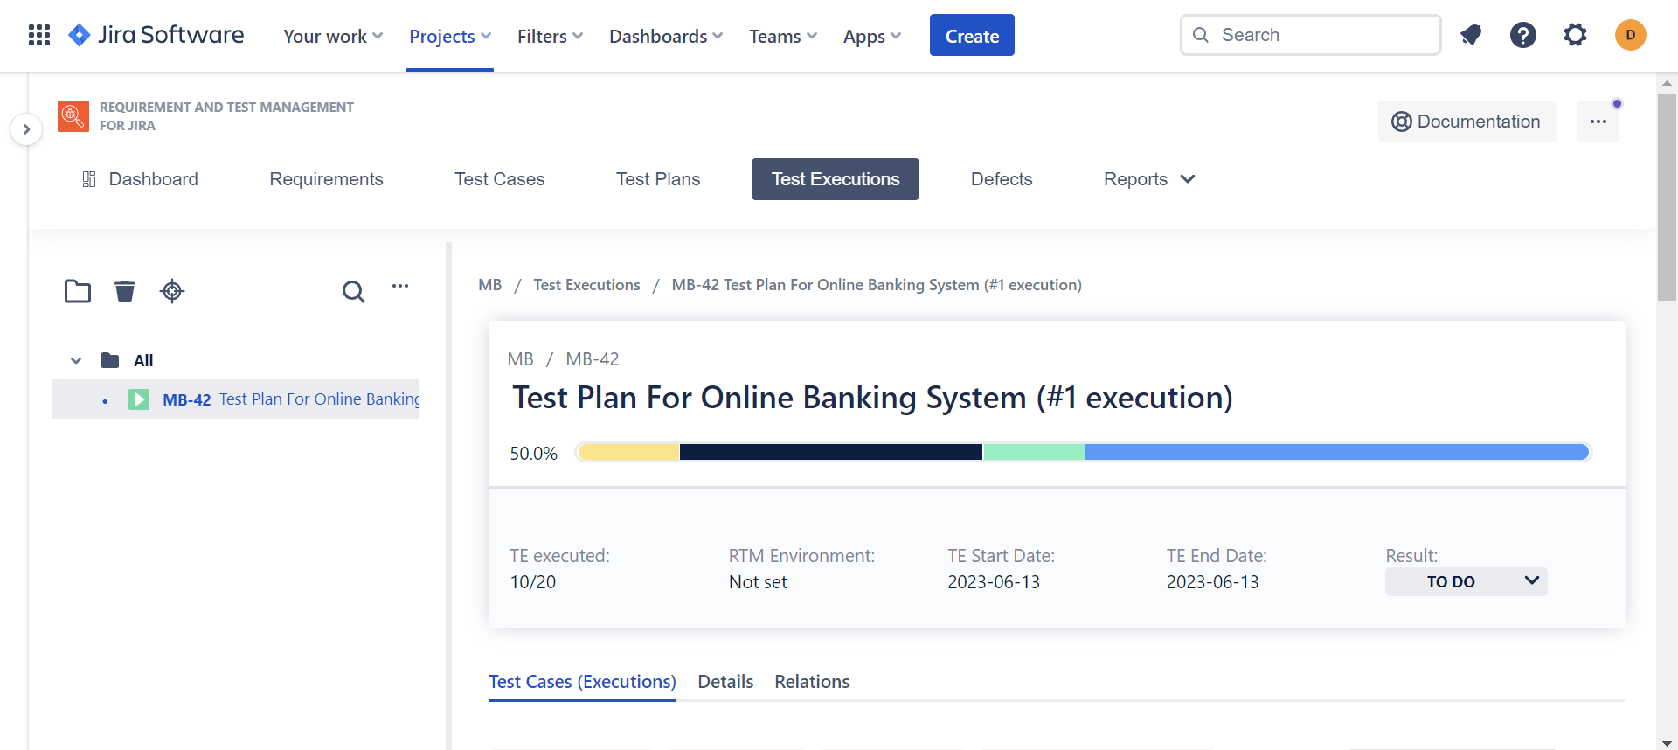

Fig4: Test Execution from Jira

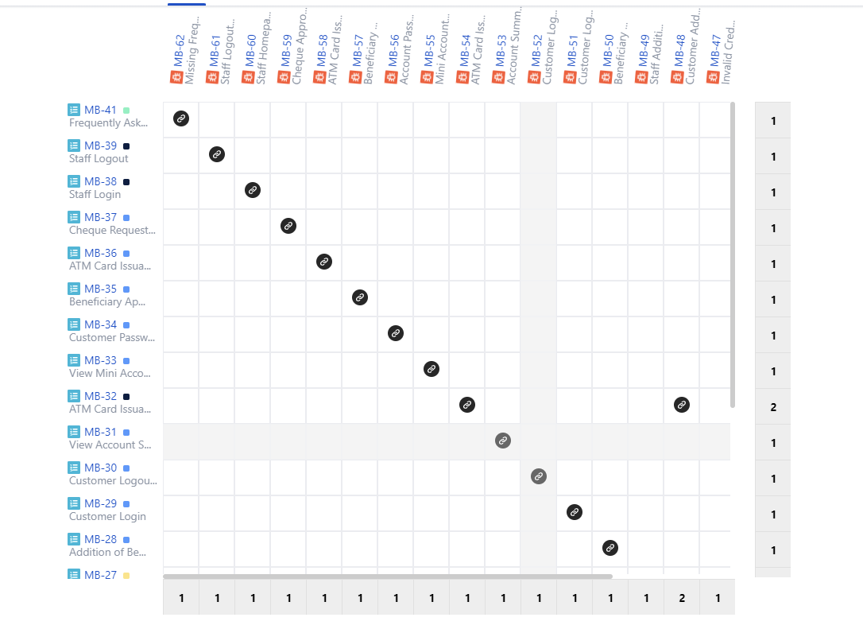

Fig5: Traceability

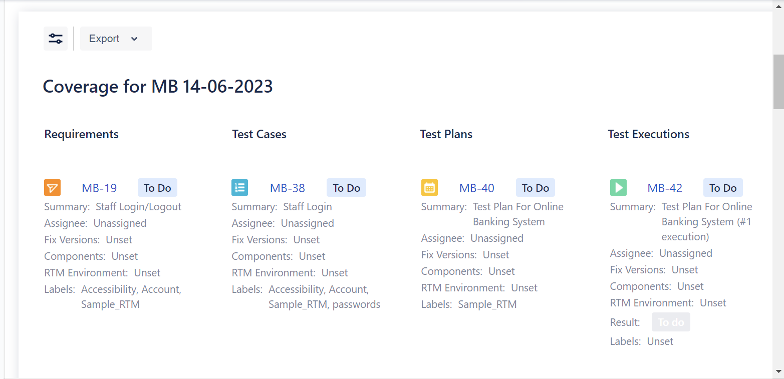

Fig6: Coverage

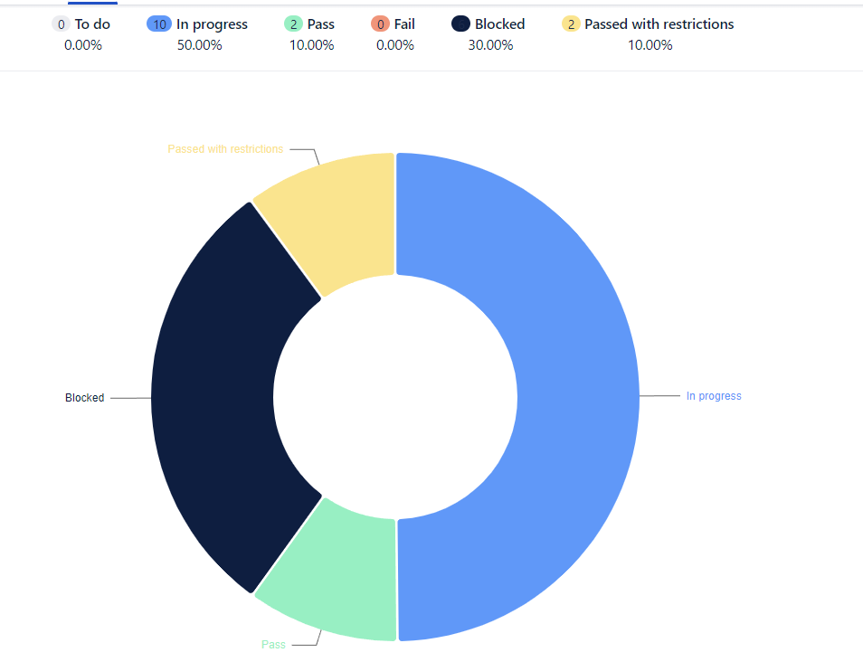

Fig7: Test Case Execution

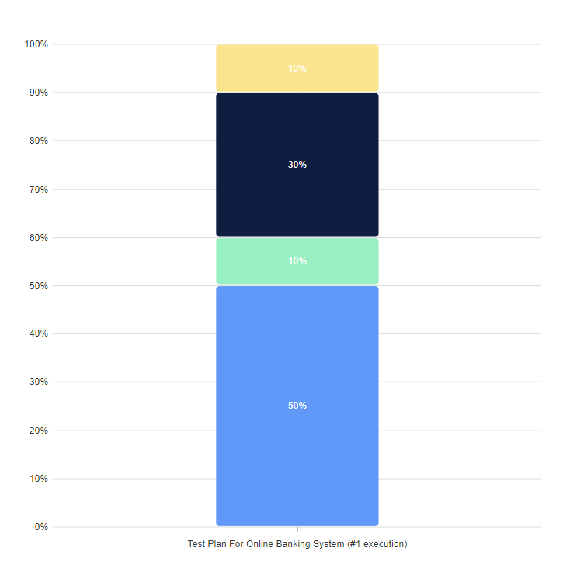

Fig8: Test Execution

1. Roadmap

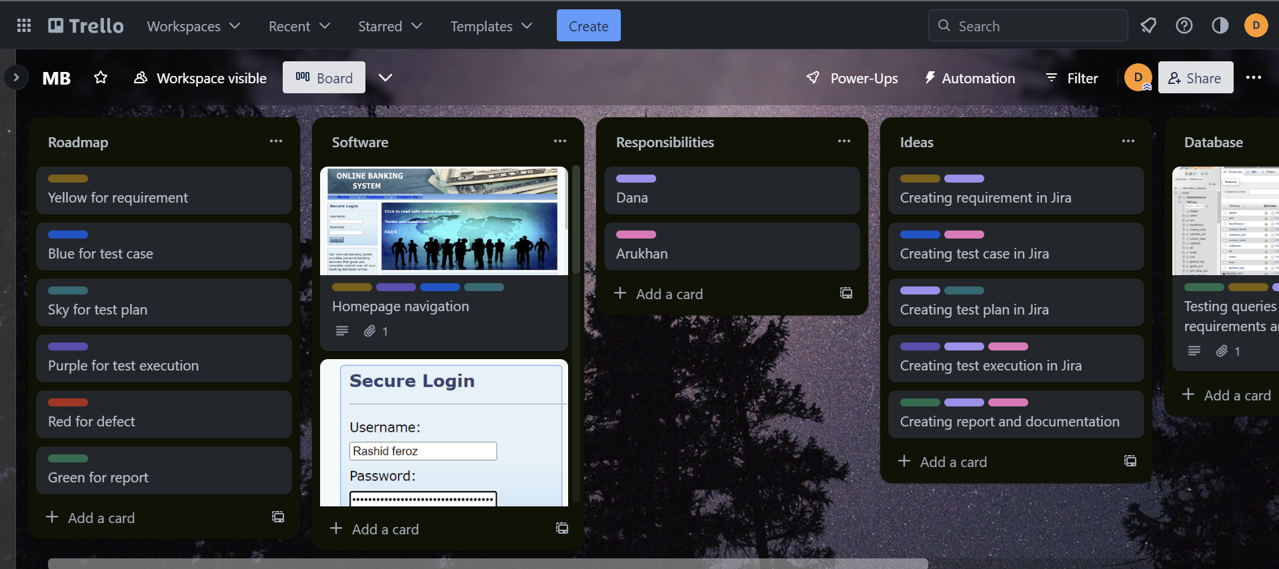

Fig9: Roadmap from Trello

1. Database

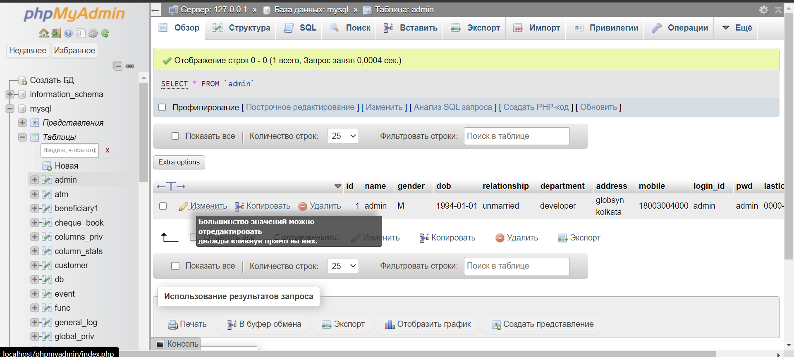

Fig10: phpMyAdmin administration

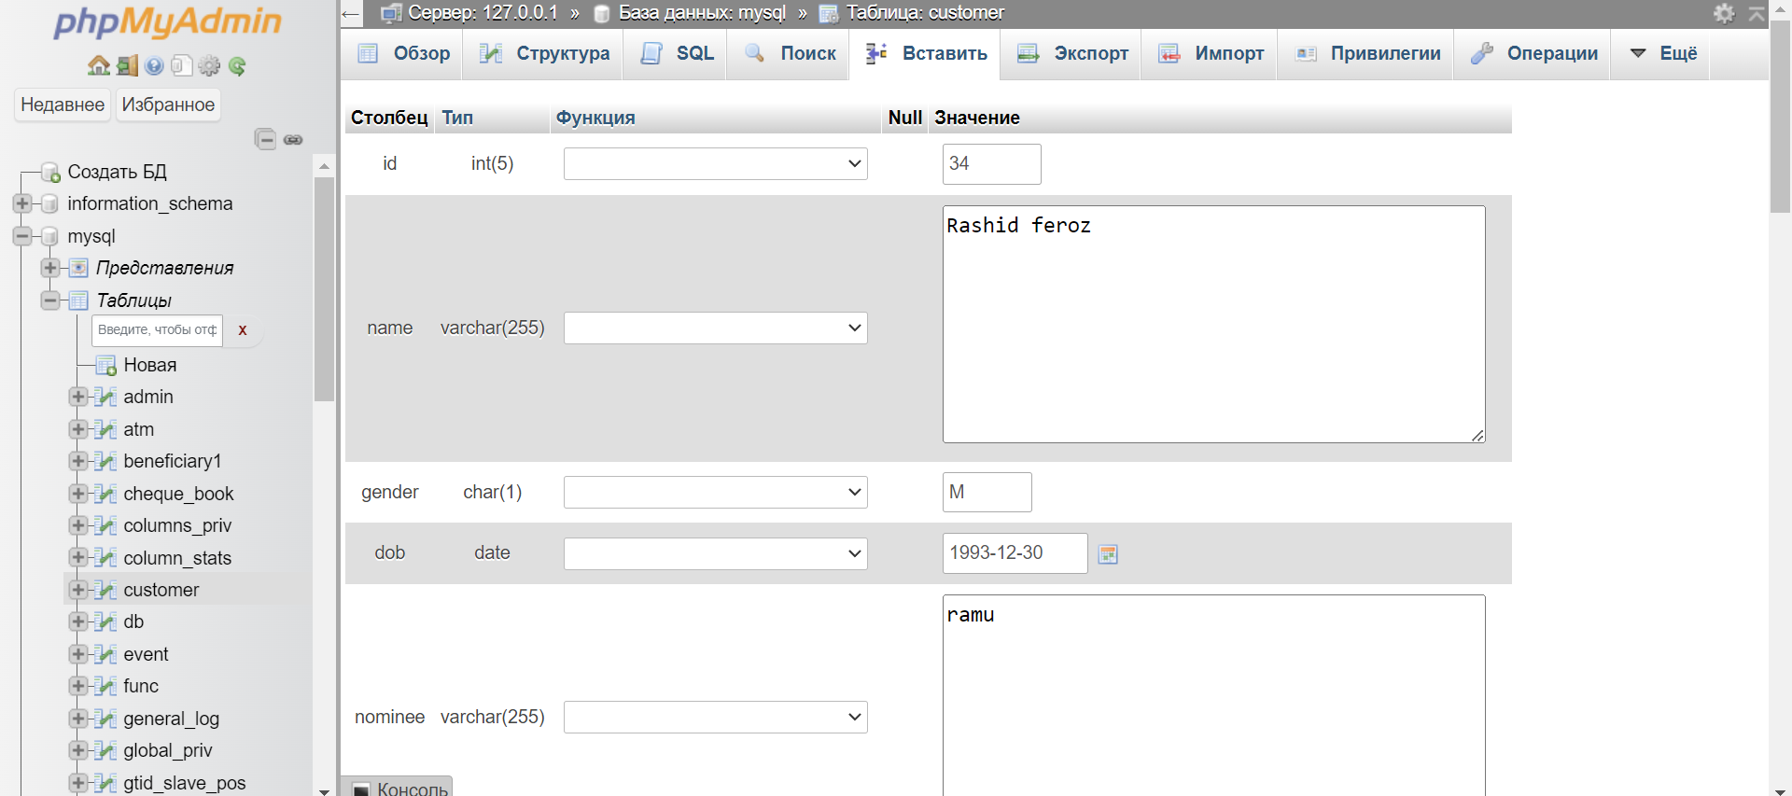

Fig11: Editing manually in phpMyAdmin

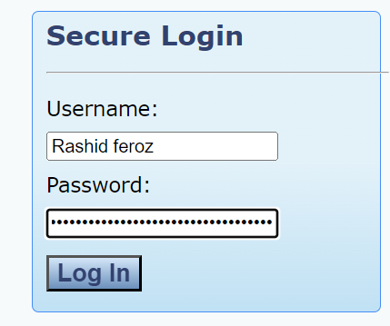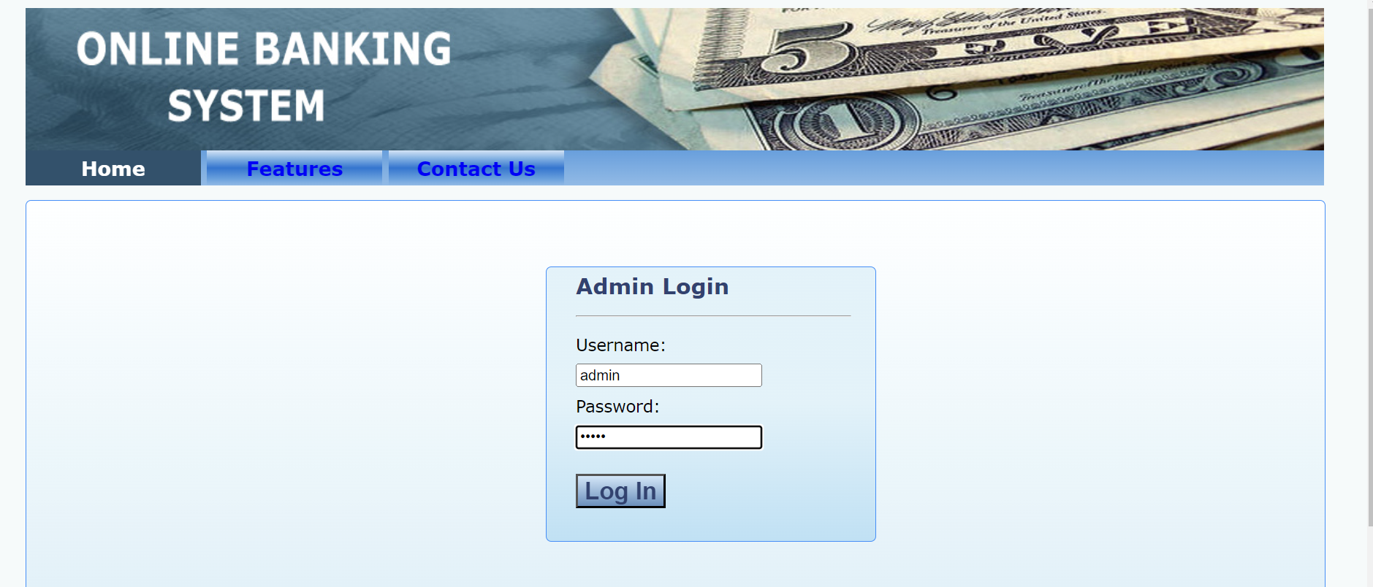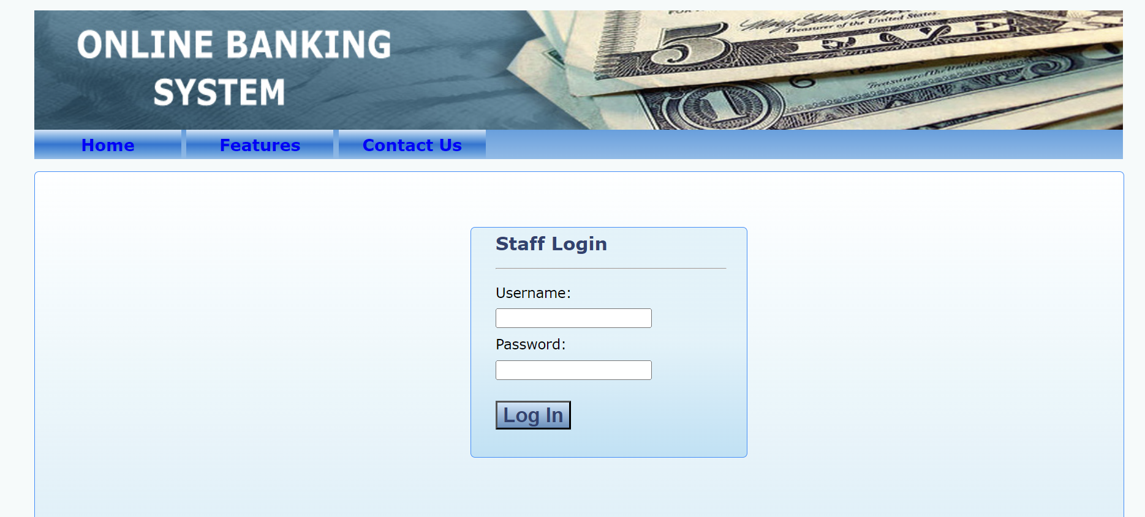

Fig12: Registration from Online Banking System

**Query**

This query is intended to extract particular transaction details from the passbook34 table for analysis and reporting.

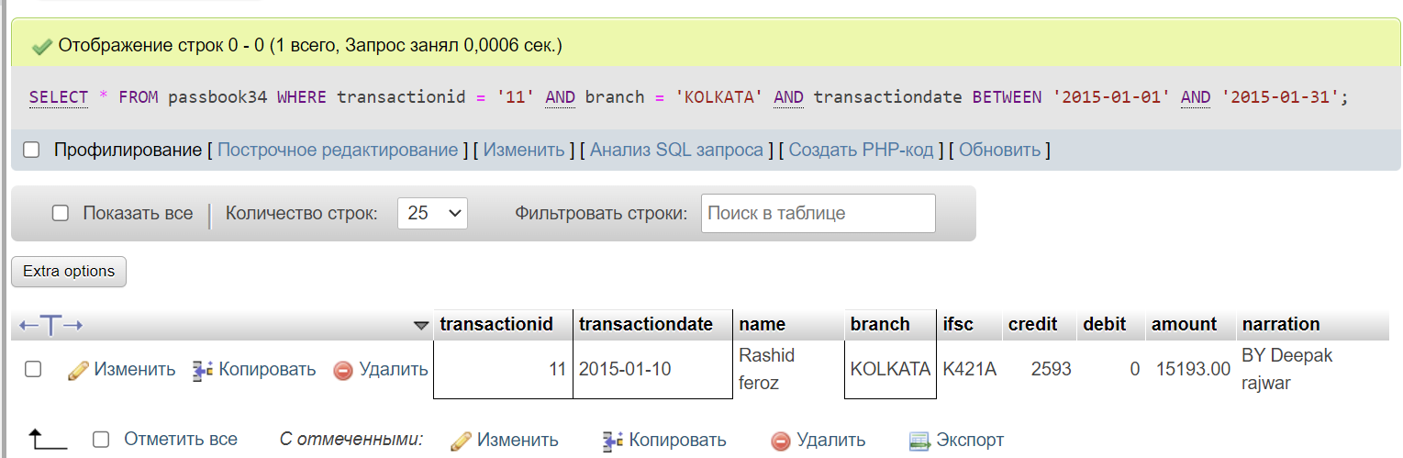

This query adds a new customer record to the customer database with the provided information.

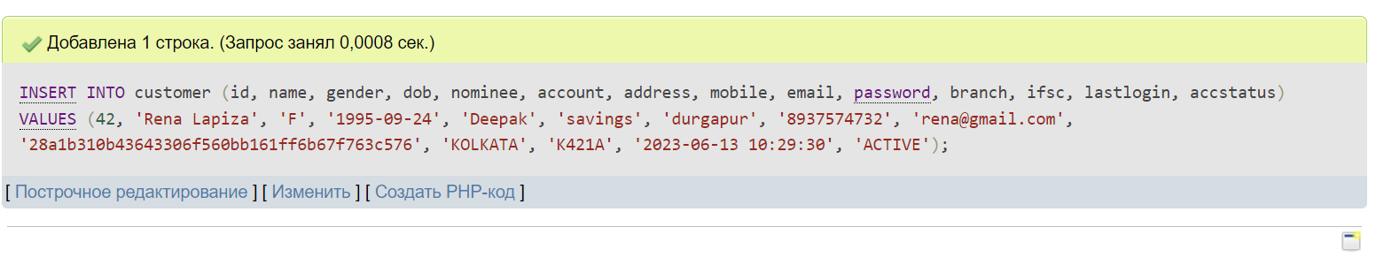

This query changes the email and phone number of a client with the customer_id 42.

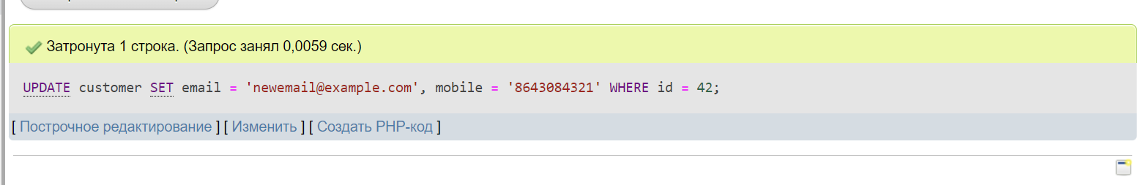

Based on the id, this query deletes a customer from the customer table.

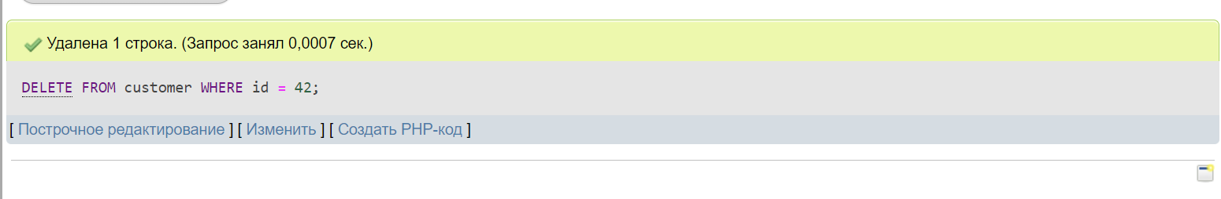

**Findings**

|  |  |  |  |  |  |  |  |
| --- | --- | --- | --- | --- | --- | --- | --- |
| Defect ID | Description | Severity | Steps to Reproduce | Actual Results | Expected Results | Status | Assigned to |
| MB-43 | Admin Homepage Access Denied | High | Try to refresh the page | The admin homepage is not accessible, and an "Access Denied" message is displayed. | After successful login, the admin should be able to access the admin homepage without any access denial. | Open | Dana Orenkyzy |
| MB-44 | Admin Logout Failure | High | Observe the behavior after attempting to logout. | The system does not log out the admin account. | The admin should be successfully logged out and redirected to the login page. | Open | Arukhan Otarova |
| MB-45 | Navigation Bar Missing | Medium | Observe the navigation bar at the top or side of the page. | The navigation bar is not displayed on the page. | The navigation bar should be visible and provide options for easy navigation | Open | Arukhan Otarova |
| MB-46 | Insecure Online Banking Experience | Medium | Observe the security features and encryption mechanisms implemented. | The online banking platform lacks proper security measures | The online banking platform should provide a secure browsing experience | Closed | Dana Orenkyzy |
| MB-47 | Invalid Credentials | Medium | Enter incorrect or invalid credentials. | The system accepts the valid credentials | Entering invalid credentials should result in an error message, | Open | Dana Orenkyzy |
| MB-48 | Customer Addition Failure | High | Observe website behavior | Customer addition fails | The system should successfully create the customer account | Open | Dana Orenkyzy |
| MB-49 | Staff Addition Failure | High | Observe website behavior | Staff addition fails, | The system should successfully create the staff account | Open | Arukhan Otarova |
| MB-50 | Beneficiary Addition Error | High | Observe website behavior | An error occurs while adding a beneficiary | The system should successfully add the beneficiary to the customer's account without any errors. | Open | Arukhan Otarova |
| MB-51 | Customer Login Issue | High | Observe website behavior | Customers are unable to log in to their accounts | Customers should be able to log in to their accounts | Open | Dana Orenkyzy |
| MB-52 | Customer Logout Issue | High | Observe website behavior under logout conditions | Customers are unable to log out of their accounts successfully | Customers should be able to log out of their accounts without any issues. | Open | Arukhan Otarova |
| MB-53 | Account Summary Display | Medium | Observe the displayed account summary details. | The account summary does not display accurate or complete information. | The account summary should provide an accurate and comprehensive overview of the user's account. | Open | Arukhan Otarova |
| MB-54 | ATM Card Issuance Request Failure | Medium | Observe the response or confirmation message | The system fails to process the ATM card issuance request | The system should process the request successfully and provide a confirmation message to the user. | Open | Dana Orenkyzy |
| MB-55 | Mini Account Statement Display | Medium | View the displayed mini account statement. | The mini account statement does not show accurate or complete transaction details. | The mini account statement should provide a concise and accurate summary of the user's recent transactions | Open | Dana Orenkyzy |
| MB-56 | Account Password Change | Medium | Enter the current password and the desired new password. | The password change process fails. | The system should successfully update the account password | Open | Arukhan Otarova |
| MB-57 | Beneficiary Approval Failure | High | Observe the response or error message. | The system fails to approve the beneficiary | The system should successfully update the beneficiary status | Open | Arukhan Otarova |
| MB-58 | ATM Card Issuance Approval | High | Observe the response or error message. | The system fails to approve the ATM card issuance request | The system should successfully process the request, generate the ATM card | Open | Dana Orenkyzy |
| MB-59 | Cheque Approval Failure | High | Observe the response or error message. | The system fails to process the request | The system should successfully update the cheque status | Open | Arukhan Otarova |
| MB-60 | Staff Homepage Access Denial | High | Observe the behavior after login. | Access to the staff homepage is denied. | The system should grant access to the staff homepage | Open | Dana Orenkyzy |
| MB-61 | Staff Logout Failure | High | Observe the behavior after attempting to logout. | The system fails to log out the staff account. | The staff member should be successfully logged out | Open | Dana Orenkyzy |
| MB-62 | Missing Frequently Asked Questions (FAQ) Section | Medium | Look for the Frequently Asked Questions (FAQ) section | The Frequently Asked Questions (FAQ) section is available | The help or support section should include a well-structured and easily accessible Frequently Asked Questions (FAQ) | Open | Arukhan Otarova |

**Recommendation**

We conducted a list of tests on the Online Banking System and concluded some lacking features of the website. Relying on the defects and disadvantages of the website, we made a list of recommendations for the further improvement of the system, which are the following:

* Enhance User Authentication: Implement multi-factor authentication (MFA) to add an extra layer of security for user logins. This can include biometric authentication, SMS-based verification codes, or hardware tokens. Strong user authentication measures help prevent unauthorized access and protect sensitive financial information.
* Implement Robust Encryption: Ensure that all sensitive data transmitted between the user's device and the online banking system is encrypted using secure protocols such as SSL/TLS. Implement encryption at rest to safeguard user data stored within the system. Regularly update encryption protocols to address emerging vulnerabilities.
* Implement Real-time Fraud Detection: Deploy advanced fraud detection systems that can analyze user behavior patterns, transaction history, and anomalies to identify potential fraudulent activities. Real-time monitoring and alerts help mitigate risks and protect customers from unauthorized transactions.
* Regular Security Audits and Penetration Testing: Conduct regular security audits and penetration testing to identify vulnerabilities in the online banking system. Engage third-party security experts to perform independent assessments and provide recommendations for enhancing system security. Address identified vulnerabilities promptly.

**Conclusion about Defects:**

In conclusion, the identified defects pose challenges and hinder the smooth functioning of the system. The cheque approval failure prevents the proper processing of cheque approval requests, potentially causing delays in transactions. The staff homepage access denial restricts staff members from accessing essential information and performing their assigned tasks. The staff logout failure results in an inability to properly terminate staff sessions, potentially compromising security. Lastly, the missing Frequently Asked Questions (FAQ) section deprives users of a valuable self-help resource, increasing their reliance on other support channels.

It is crucial to address these defects promptly to enhance the overall user experience, streamline administrative processes, and ensure the system's reliability and security. The assigned students, Arukhan and Dana, play vital roles in investigating and resolving these defects. By resolving these issues, the system can improve functionality, security, and user satisfaction, resulting in a more efficient and user-friendly application or website.

**Testings:**

Functionality testing of the Online Banking reveals that there are issues with authorization with the system, since it does not get access to an admin or staff site. And produce a fatal mistake deploying the MySQL connection's password. It also needs you to travel to the registration page by modifying the website's address, which makes it difficult to navigate.

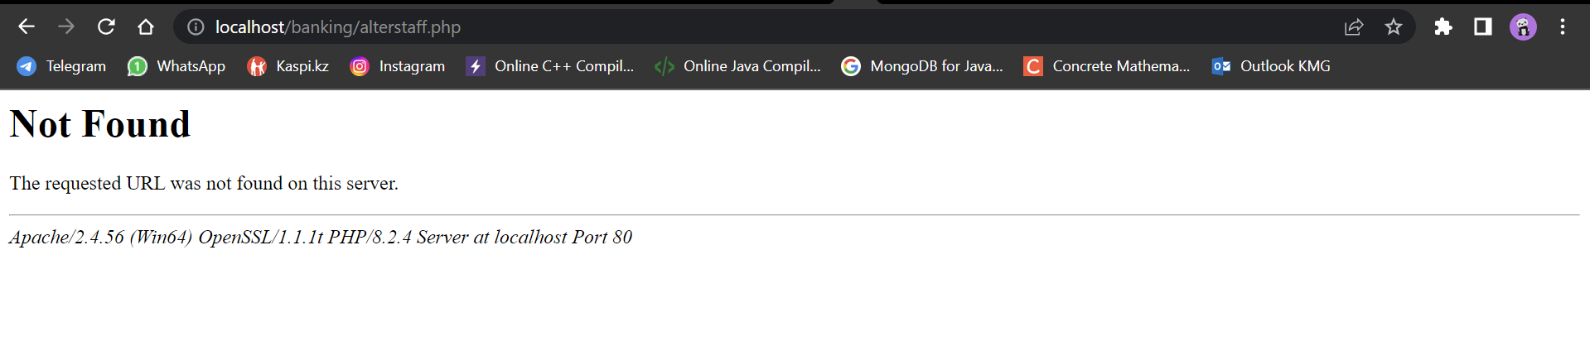

Fig12: Functionality Testing

Security testing informs the consumer at registration that their password is risky and must be changed. When a consumer fails to fill out the login and password fields, the system alerts him. The password field is appropriately encrypted.

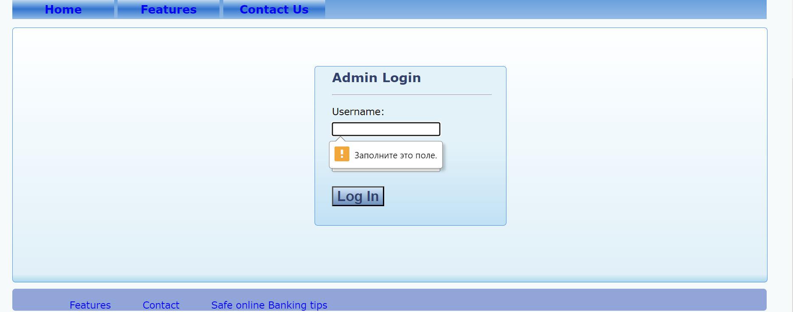

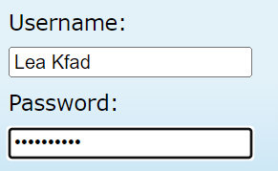

Fig13: Security Testing

Usability The system's testing reveals that the main page contains some simple operations and navigation for the vital components such as the navbar, footer for information, features, and various other specifics that may be of interest to a client.

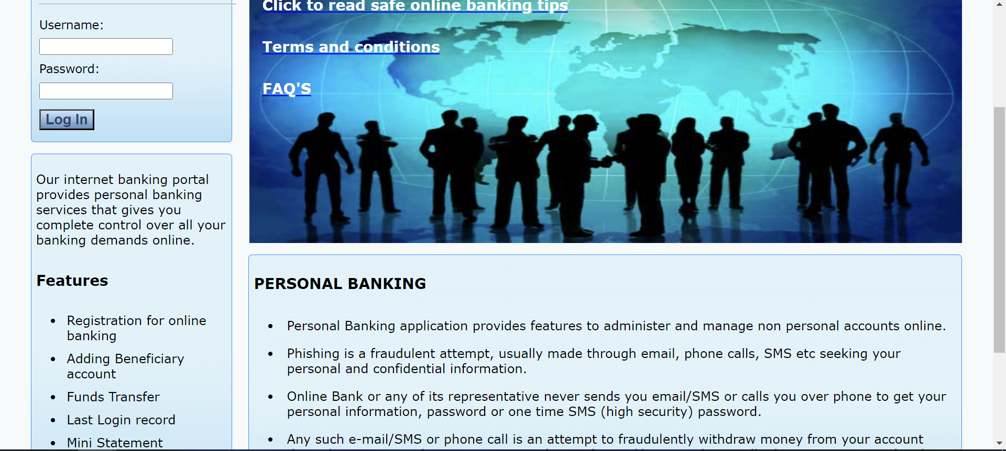

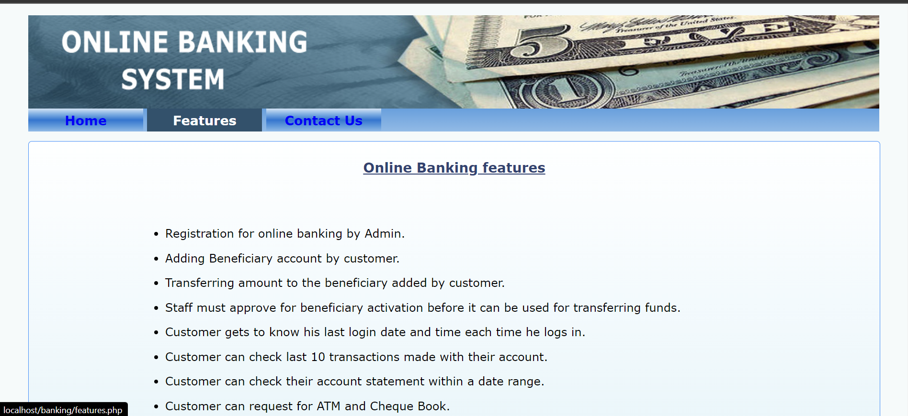

Fig14: Usability Testing

Performance testing the system reveals that when the number of requests increases and the transaction load increases, the website becomes unreachable and freezes.

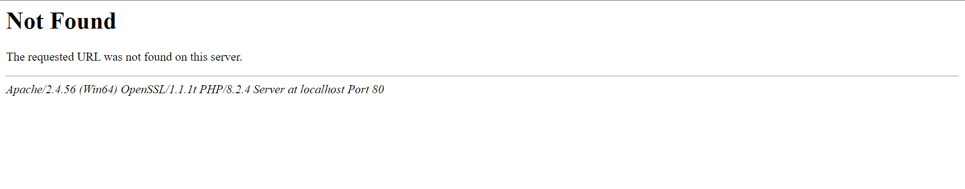

Fig15: Performance Testing